**LAB PROJECT**

**&**

**Open ended lab report**



**Spring 2025**

**CSE102L COMPUTER PROGRAMMING LAB**

**Submitted By: Muhammad Tariq**

Reg No: 24pwcse2378

Class Section: A

**Submitted To:**

**Engr. Abdullah Hamid**

**July 2, 2025**

Department Of Computer Systems Engineering

University Of Engineering And Technology, Peshawar

**Project Title:**

Basic E-commerce product catalog

**Project objectives:**

The main objective of this project is to develop a basic e-commerce product catalog system that allows users to manage product listings and simulate a shopping cart experience. It enables users to:

* Browse and manage products (add/remove).
* Add products to shopping cart.
* Simulate the checkout process.
* Save purchase receipts to a file.

**Open Ended Lab Statement:**

Your Project must contain the following points:

* The program must serve a real-world problem using concepts of OOP and File IO.

You must use Structures or Classes in some context and utilize fstream library in C++.

* The program code must be modular.

**Project Flow Chart:**

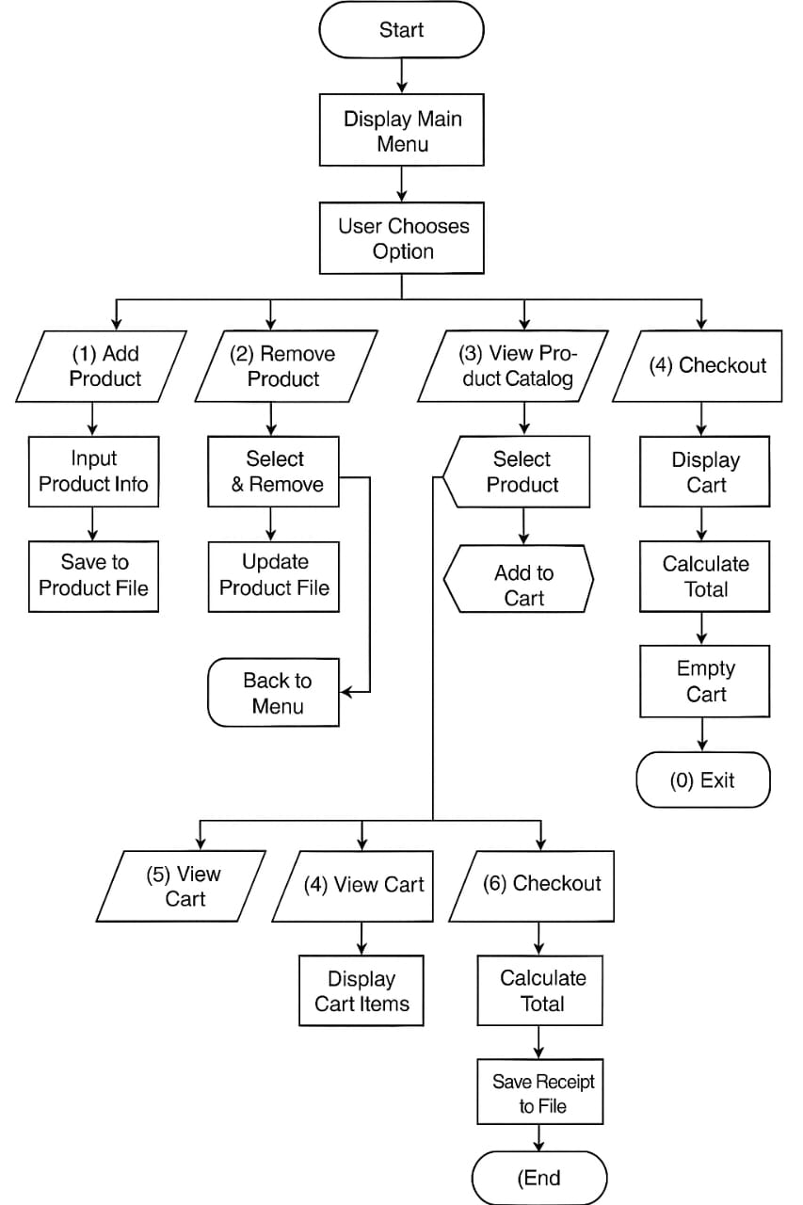

**Project Code Screenshots:**

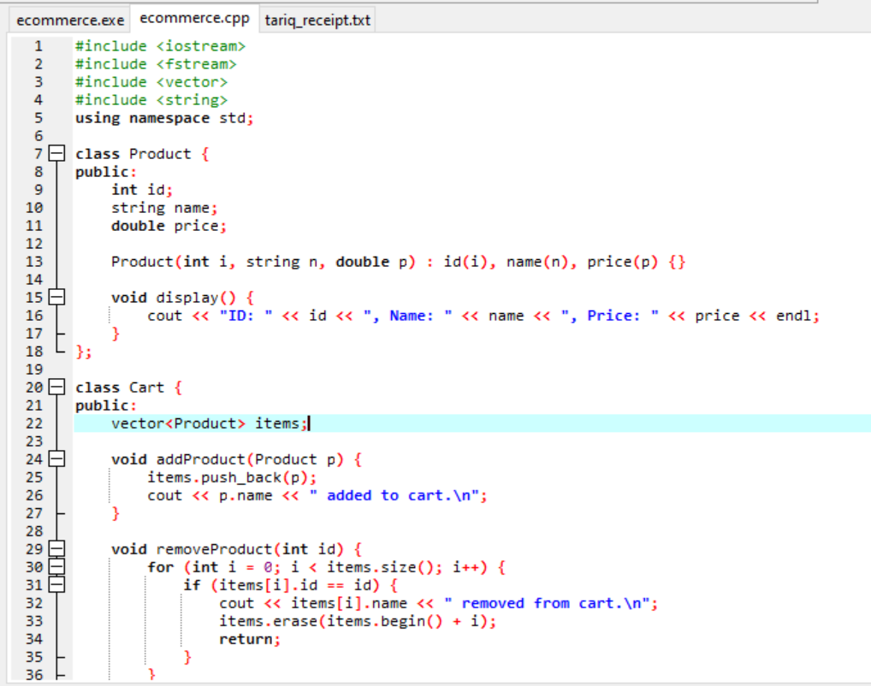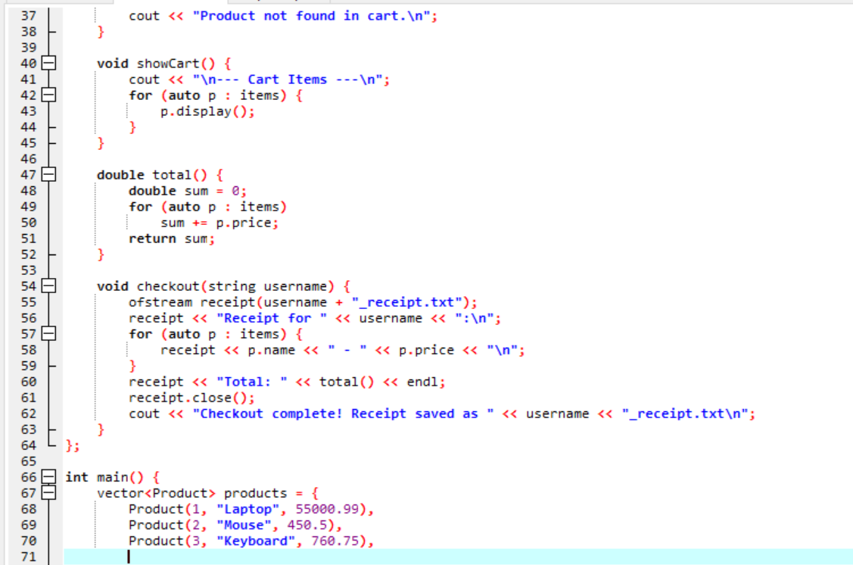

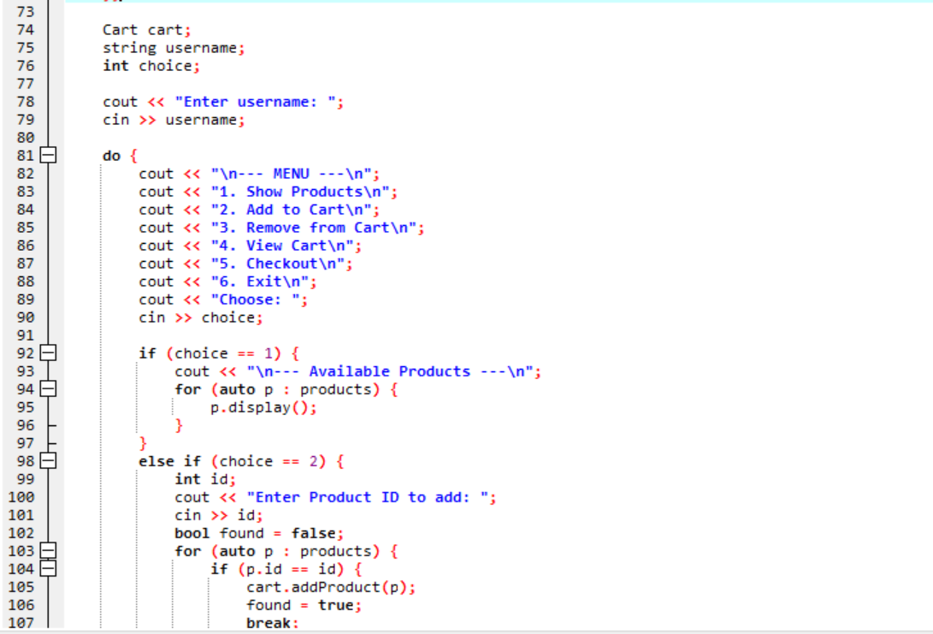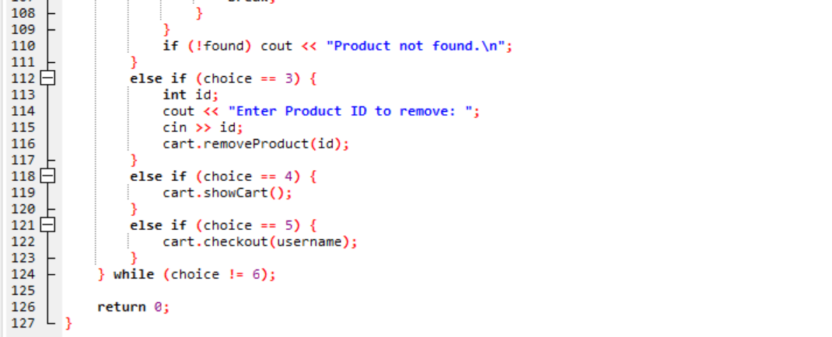

**Project Output Screenshot:**

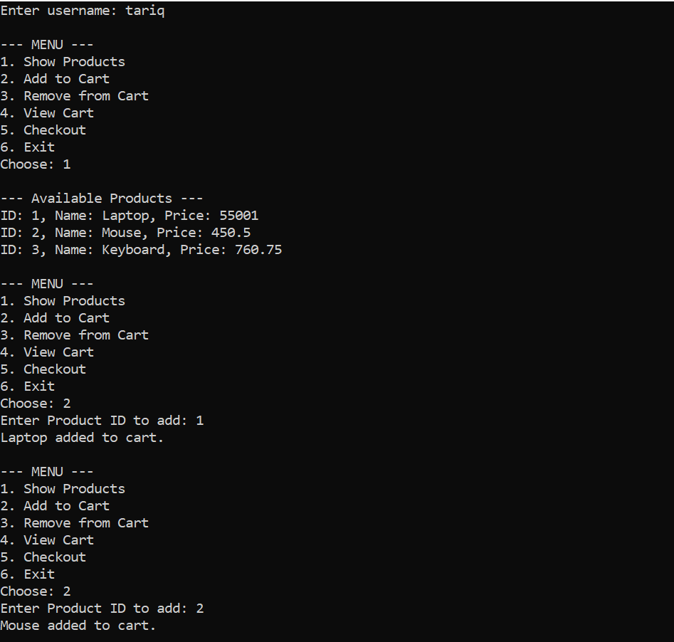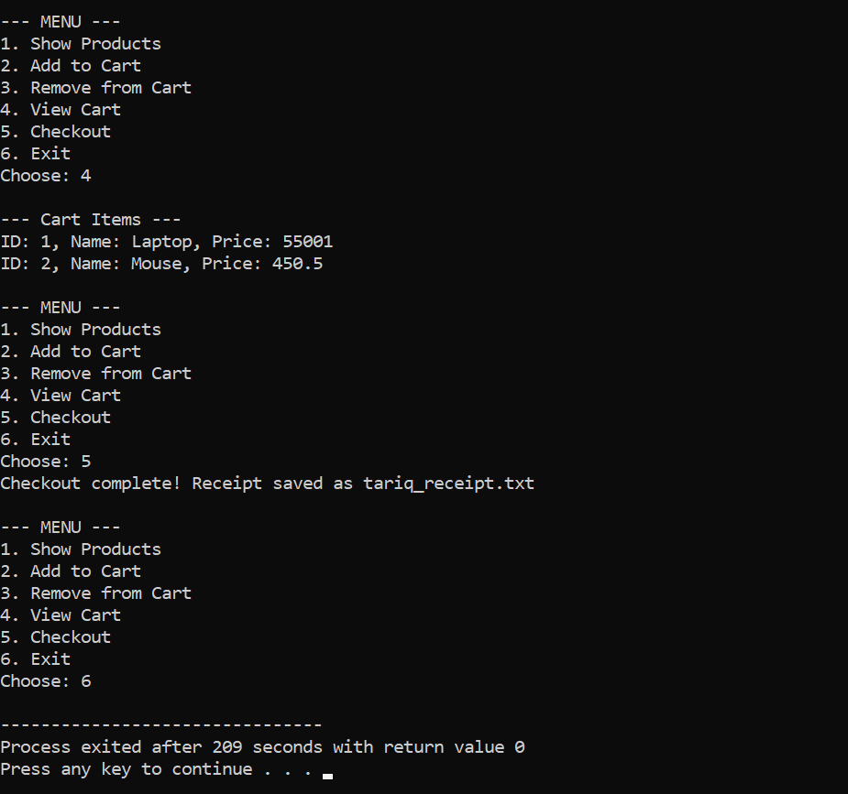

**Purchase receipt:**

